Emerald City Medicinal’s “REVAMP OUR LOGO” Contest
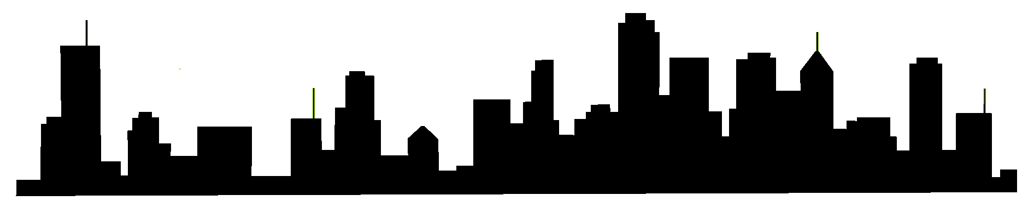
Emerald City Medicinal is a locally owned and operated dispensary in Eugene. We are ready to give our logo a facelift and we want your help!
How to Enter the Contest
The contest begins on February 23rd, 2018. Submissions will be accepted through April 10th, 2018. Winners will be announced on our social media pages, website, in-store and by direct contact to the winners' email accounts.
Eligibility
Contest is open to legal residents of the United States and its territories who are 18 years or older at time of entry.
Entries should be
- Submitted directly to emeraldcitymedicinal@gmail.com. Please use “LOGO” in the subject line.
- Submit the design in a usable web version, (.jpg or .png), and a scalable vector, print quality version of the logo. The logo must adapt well to electronic and print media, to reproduction on small and large surfaces, and to use in color or grayscale.
Design Requirements
- The logo may be featured on our website, social media platforms, signage, printed material, caps, t-shirts, etc… Therefore, the logo should be both eye-catching and legible.
- The logo should somewhat incorporate our current skyline logo. We would like our logo to have more of a “Eugene” feel. Think buttes, rivers, etc…
- It is not necessary to use the current skyline in it’s entirety or in it’s current form.
- Please limit colors to no more than 3 colors. The design should also look good in black and white.
- The logo should not contain text.
- The logo cannot contain copyrighted material, licensed or previously published images. The design must be easily reproducible and scalable for large and small formatting.
Contest Details
Winners will be selected by the owners and staff of Emerald City Medicinal. Contestants agree that ECM may publish their logo and name and may use both for advertising campaigns and/or marketing materials in the future. Winner assigns all ownership rights, including all intellectual property rights to the logo, to Emerald City Medicinal. Additionally, Emerald City Medicinal may alter, modify or revise the logo as it sees necessary to achieve the goals of the business. Emerald City Medicinal reserves the right to not select a winner if, in its sole discretion, no suitable entries are received.
Prize
Contest winner will receive a $250 cash prize.

