Scholarship Opportunity
For Art Students and Faculty

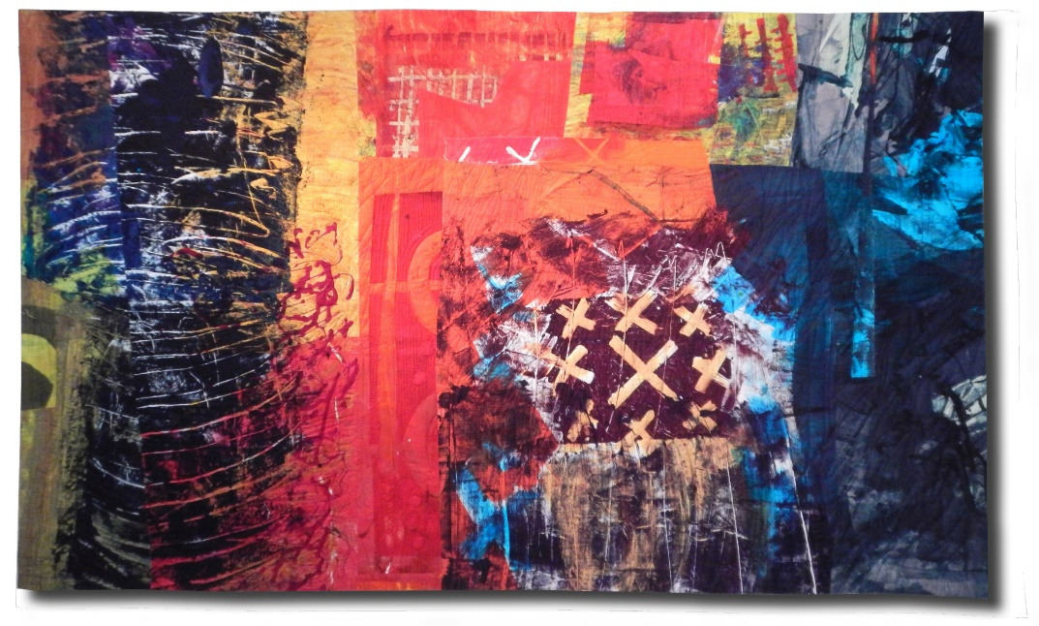
Normandy by Pat Pauly.

Studio Art Quilt Associates (SAQA) is an international non-profit organization dedicated to promoting the art quilt and the artists who create them. Oregon SAQA members will be holding a conference, Unpredictable Outcomes, at Lane Community College in Eugene on October 18th, 2018.

Art students, teaching assistants, and faculty members are invited to apply for one of four scholarships to attend this daylong event. The scholarships cover all registration fees and include a delicious lunch provided by LCC’s Culinary Arts department. If you have an interest in fiber arts, textiles, or just want to learn about the possibilities of working with fiber and thread to create art, please apply!

Come and see presentations on
- Unpredictable Outcomes: contemporary fiber artist Pat Pauly from Rochester NY.
- Dealing with Oops: local artists panel
- Curatorial Conundrums: Michael Fisher, Maude Kerns Art Center
- Conversations about SAQA’s Mentoring program and entering juried shows.
- Showcase Exhibit of 12 x 12 quilts

Four scholarships are available. Undergraduate and graduate students and faculty involved in the arts & design and arts education at the University of Oregon, Oregon State University and Lane Community College may apply. Members of Maude Kerns Art Center in Eugene and Emerald Arts Center in Springfield are also eligible to apply. Application deadline: June 1, 2018.
Interested? Fill out and submit the application form (separate document).
Questions? Email schrock32@gmail.com

