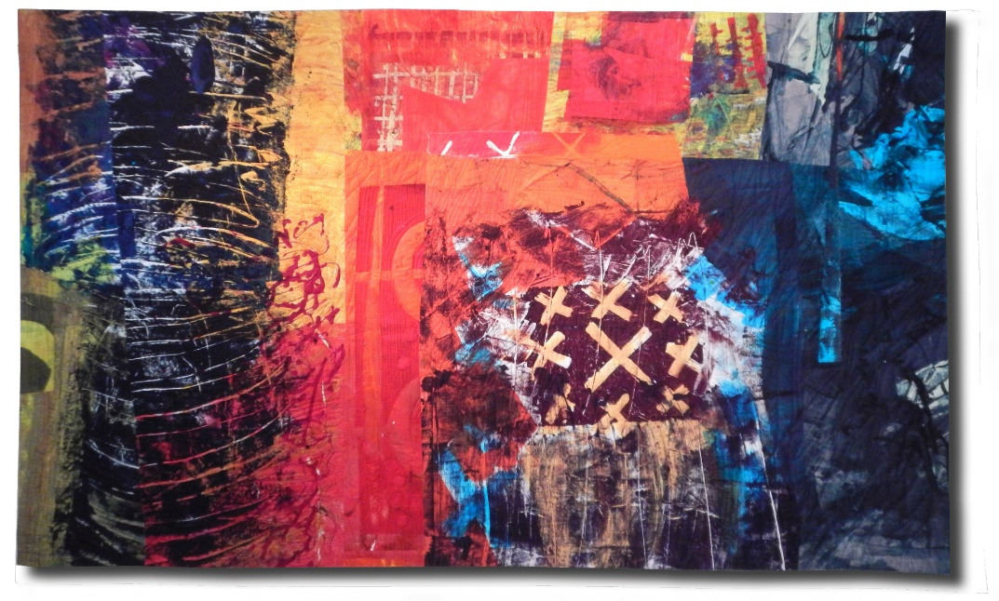

Unpredictable Outcomes Scholarship Application
Oregon SAQA Conference, Oct. 18th, 2018

Please complete this form and email to schrock32@gmail.com by August 31st, 2018. Winners will be contacted by June 30th.
Name: ______________________________________
Email: ___________________________________
Institution you attend: ____________________________________________
Major/Primary Art Interest: _________________________________________
In no more than 150 words, please tell us how attending the conference will enhance your personal or professional art practice.

