Dear University of Oregon students and community,
The Hudson Valley Art Association is excited to announce that in the summer of 2019, we will be offering two artists’ workshop sessions in Perugia, Italy. Further we on the HVAA board are particularly proud to announce that we are able to offer scholarship money for young artists aged 18-24 to cover the cost of attending the workshop of their choice.
We encourage all those that are interested to apply for the scholarship opportunity. A link to the application can be found on HVAA’s website here: Travel Scholarship
Application Deadline: Dec. 31, 2018
While the scholarship is limited to young artists, artists of all ages and skill levels are invited to participate. Each session will have four instructors from across the U.S. teaching a total of eight unique courses, both studio-based and en plein air. Beyond the workshops in Perugia, travelers will enjoy a couple of days touring the museums of Rome, and day trips to both Florence, and Siena.
If you’d like further information about the workshops please visit HVAA’s travel page where you can see an overview of the workshops, and download a PDF brochure with full course descriptions and instructor bios here: Perugia Workshops
Should you have questions, or would like to receive a full day-to-day itinerary and payment breakdown, please email board member James Adkins: james@hudsonart.org
We hope that you’ll be able to join us in Perugia for what is sure to be an enriching and unforgettable experience.
Regards,
The Hudson Valley Art Association’s Board of Directors
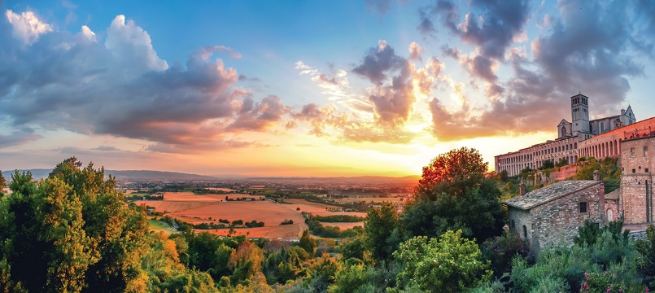
Follow HVAA on social media:
Facebook: HVAA or Perugia Workshops Group
Instagram: HVAA

