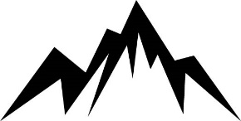
About Us
High Peak Medical Systems is an Oregon Limited Liability Corporation (LLC) whose mission is to eliminate false-positive blood cultures caused by contamination of the sample during the blood collection process.
With its patented design, High Peak Medical’s device is designed to divert and sequester potentially contaminated blood, ensuring a clean sample and preventing the incidents of false-positive blood cultures.
Position: Contract Industrial Designer
Job Location: Remote
Responsibilities:
- Apply industrial design to the High Peak product with the use of 3D CAD.
- Ensure that the High Peak product design is aesthetically and visually pleasing for easy customer adoption.
Qualifications:
- Experience in 3D CAD modeling
- Portfolio showing industrial design capabilities
Education:
- Pursuing a Bachelor’s degree in Industrial Design or related discipline
Contact the CEO at Hammer@HighPeakMedical.com or call at 571-299-9875 to apply.

