Dear Artist,

You are invited to apply for one public art opportunity at the University of Oregon’s student union; Erb Memorial Union (EMU), located in the heart of the Eugene campus.

Commissioned opportunities include one interior project with a budget of approximately $18,000. Funding for this project is made possible through the EMU Art Committee, Adell McMillan Foundation and EMU Administration. Budgets may be adjusted as the selection process proceeds.

Erb Memorial Union (EMU)

The original portion of the EMU is a brick building built in 1950. The building was an instant hit with students, acting as a unifying space for students, staff and faculty to gather in community. The EMU has historically been, and remains a popular location for students to study, enjoy time with friends and access beneficial resources. Additionally, the EMU has been a popular site for political demonstrations since the1960s (see video, Meet Me at the S.U., listed at the end of this document). The Fishbowl, Taylor Lounge and McMillan Gallery, are part of the original 1950 design, and continue to be popular areas today.

In 2016, the EMU underwent significant renovations to update the historical space and add onto the existing building. This new portion of the building created additional spaces for student services and programs, including a new north entrance.

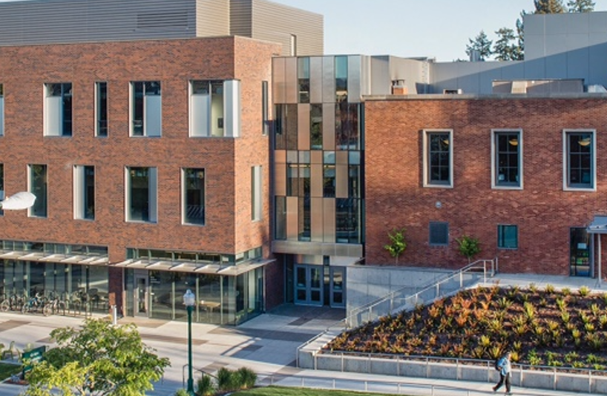
(North entrance doors: exterior)
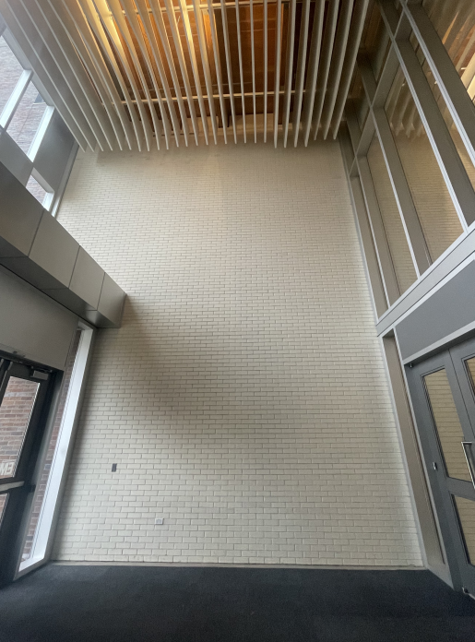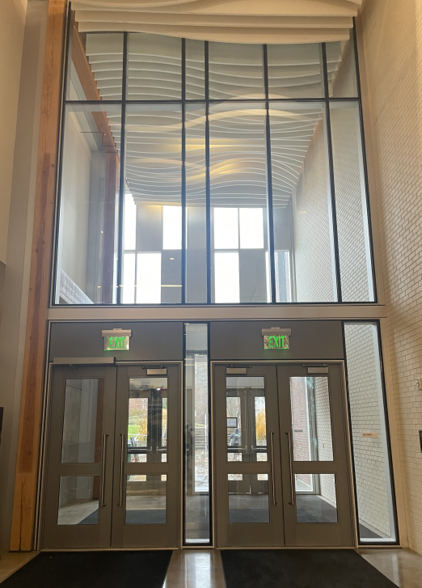
(North entrance wall: interior) (North entrance doors: interior)

EMU Commissioned Art

The EMU’s north entrance has a two-story white brick wall, which is the site for this commission (pictured above). The EMU is open to variety of mediums such as mural, sculptural installment, stained glass, and other styles of artwork appropriate for the location.

The new piece should welcome all members of our community to the EMU, and should also focus on the diverse and inclusive environment that the EMU fosters.

The Aztlan-Topializtli piece pictured below, is a significant piece of art that was donated to the EMU in the 1980s, and provides a good example of this kind of work already existing in the building.

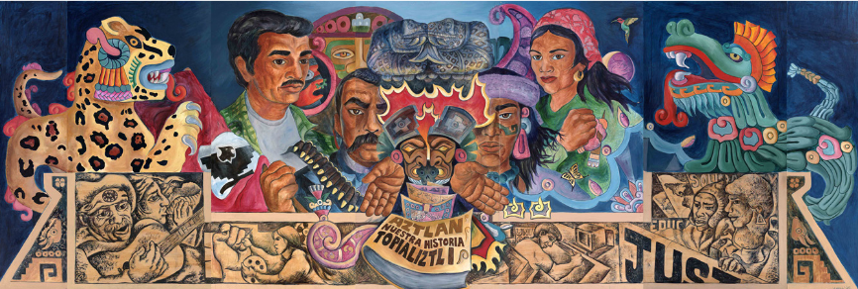

Special Instructions to Applicants

To be considered as an artist for an original work of art at the EMU, please submit the following documents to emu@uoregon.edu by 5pm on February 1, 2023:

In one PDF document please include the following:
- A short letter (maximum 5 pages) describing…
  - Your past public artwork, particularly in academic settings;
  - Your specific interest in this project;
  - Any connection you might have with the University of Oregon;
  - A brief outline of the artwork you plan to create in the space; and
  - A brief description of how you might engage students in your design process.
- Resume: Maximum two pages; and
- List of your images with a one-sentence description of the work; sizes; materials; year completed; budget; and commissioning agency

In a separate PDF document, please include:
- Up to ten images of your past work (do not exceed 3MB)

Submit all application materials to emu@uoregon.edu by 5pm February 1, 2023

Selection Process
The EMU Art Committee will review applications and select finalists.

Finalists will be required to provide the contact information of two professional references, and attend a 30 min Zoom discussion, regarding their interest in creating an art installation at the EMU.

Tentative Schedule
February 1, 2023 Applications due
March 1, 2023 Finalists selected
April Zoom discussions with finalists
May Artist selected
June- August Artwork fabrication and installation

For questions and more information contact: emu@uoregon.edu

More about the EMU
Meet Me at the S.U. – A History of the Erb memorial Union: https://www.youtube.com/watch?v=w0shjBXzlOQ

https://emu.uoregon.edu/

https://www.instagram.com/uoemu/

