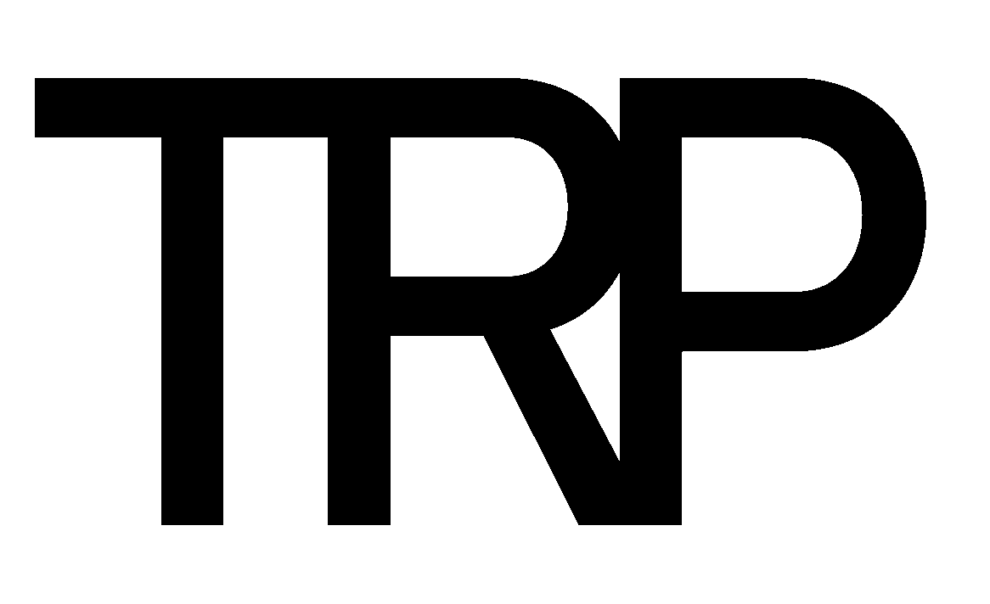

Job Description: Graphic Design Intern Last Update: February 2023
Reports to: Developed by:

Purpose

Core Responsibilities
Reasonable accommodations may be made to enable individuals with disabilities to perform the essential functions.
- Create and design print and digital materials
- Retouch and manipulate images
- Use graphic design software and work with a wide variety of media
- Collaborate with the Creative Director and Graphic Design Manager to develop design concepts
- Receive feedback from the Creative Director and Graphic Design Manager and make necessary changes
- Partner with Marketing team on creative for packaging, flyers and online assets
- Adhere to brand guidelines and complete projects according to deadline

Qualifications:
Required:
- Passion for and knowledgeable about Cannabis
- Passion for cannabis Culture
- Graphic Design major preferred
- Basic knowledge of layouts, typography, line composition, color, and other graphic design fundamentals
- Experience with InDesign, Adobe Photoshop, and Illustrator
- Strong creative and analytical skills
- Compelling portfolio of graphic design work
- Excellent organizational skills and ability to meet deadlines
- Ability to work and lead cross functional teams
- Must have excellent problem solving skills
- Able to clearly outline objectives, and create, assess and evaluate timelines
- Consistently delivers high-quality outputs with strong attention to detail.
- Works effectively under tight deadlines, respond to changing priorities and coordinate multiple assignments and meet deadlines
- Refined proficiency in creative writing, public speaking, and interpersonal business communication.

Preferred:
- Bachelor degree preferred or minimum of 2 years’ experience in similar position

Competencies:
- Thorough understanding of the Cannabis industry
- Business Acumen
- Communication Proficiency
- Ethical Conduct
- Leadership
- Relationship Management
- Performance Management
- Personal Effectiveness/Credibility

Work Environment:
This job operates in a professional office environment. This role routinely uses standard office equipment such as computers, phones, and photocopiers. This position regularly requires long hours and frequent weekend work.

Physical Demands:
While performing the duties of this job, the employee is regularly required to talk and hear. This employee is frequently required to stand, walk, use hands or feet, reach with hands and arms and may be required to lift a minimum of 50 pounds.

Position Type and Expected Hours of Work:
This is a full-time position. This position regularly requires long hours and frequent weekend work.

Travel:
This position does not require travel.

Other Duties:
Please note this job description is not designed to cover or contain a comprehensive listing of activities, duties or responsibilities that are required of the employee for this job. Duties, responsibilities and activities may change at any time with or without notice.

TRP is an Equal Opportunity Employer:
TRP is proud to be an equal opportunity employer and is committed to creating a diverse and inclusive environment. All qualified applicants will receive consideration for employment without regard to race, color, religion, sex, ancestry, age, marital status, sexual orientation, gender identity, disability, veteran status or any other classification protected by law.

Signatures

This job description has been approved by all levels of management:

Manager_______________________________________________

HR____________________________________________________

Employee signature below constitutes employee's understanding of the requirements, essential functions and duties of the position.

Employee_____​_________________________ Date_____________

